ADVANTAGES TO LOCATING DISTANCE EDUCATION ON-LINE ENROLLMENT KIOSKS AND TRAVELER BOOTHS AT BALTIMORE-WASHINGTON THURGOOD MARSHALL INTERNATIONAL AIRPORT

Report Part 3

by

Jeffrey E. Walker
AlkerJ & Associates Educational Consulting
Columbia, Maryland
alkerj@verizon.net
410-9971284

Research Support

Center of Black Business
History, Entrepreneurship and Technology

IC2 Institute

University of Texas at Austin
“What Starts Here Changes the World”

2005

ADVANTAGES TO LOCATING KIOSKS AND TRAVELER BOOTH
AT BALTIMORE-WASHINGTON INTERNATIONAL AIRPORT

By

Jeffrey E. Walker

BWI’s advantages

There are several reasons that provide the basis for the Walker Education Consultant Group’s selection of the Baltimore-Washington Thurgood Marshall International (BWI) Airport as the location of the Airport Traveler’s Booth and Kiosk pilot program proposed for consideration and adoption by the On-Line Distance Education Industry. According to a report, “Passenger Growth at Baltimore/Washington International Airport,” by Jonathan Dean, manager of communications for BWI Airport, BWI is central to the fourth largest metropolitan area in the United States - the Baltimore-Washington Corridor. The central place location of BWI is reflected in passenger increase statistics. In 2003, there were 19.7 million passengers, an increase of 3.6% since 2002, compared to the nationwide average, which showed a decline of 2.7%. There was also an increase in international passenger figures in 2003, about 11.6% from 2002 totals, compared to a national decline of 1.8% in international passengers.

The largest carrier is Southwest Airlines (161 daily non-stop flights to 35 destinations) has a market share 47% of all passenger traffic at BWI. Other airlines, American, AirTran, Delta, United and USAirways, Frontier, Northwest, Continental and United all posted positive growth numbers in 2003,. as reported by the Federal Aviation Administration. See Tables I.and 2 .
Table 1
GENERAL PASSENGER STATISTICS:
 | 2003 | 2002 | 2001 | 2000
Average Number of Passengers per Day | 53,962 | 52,089 | 55,808 | 53,559
Total Passengers per Year (millions) | 19.70 | 19.01 | 20.36 | 19.64
Percentage Change from the previous year | 3.6% | -6.7% | 3.9% | 12.4%
Source: FAA CY2003

Table 2
Total Daily Arrivals and Departures (12/02):
Average Scheduled Domestic Passenger Flights | 648
Average Charter Passenger Flights | 15
Scheduled International Nonstop Flights | 22
Average Cargo Flights | 30

SOUTHWEST TERMINALS SITE FOR KIOSKS AND TRAVEL BOOTHS

In the initial development of the kiosk and traveler booth airport distance enrollment pilot project suggested for the Distant Education On-Line Industry, the terminal/piers used by Southwest Airlines at BWI is proposed as the location for the kiosks and traveler booths. Southwest Airlines is the largest carrier at BWI (161 daily non-stop flights to 35 destinations in 2003) and has a market share of 47% of the total number of passengers that fly in and out of BWI.. Other airlines, American, AirTran, Delta, United and USAirways, Frontier, Northwest, Continental and United all posted positive growth numbers in 2003. as reported by the Federal Aviation Administration. See Table 3.

Table 3

BWI TOP FIVE MARKET CARRIERS

Top Five Passenger Airlines  by Market Share CY 2003 | Southwest (46.95%)  American (7.94%)  AirTran (7.70%)  Delta (7.41%)  United (6.92%)
Source: FAA CY2003

The arrival and departure gates for Southwest are located in both Terminal/Pier B and Terminal/Pier C, the latter serves only Southwest Airlines passengers. See Figure 1. In addition to the largest number of Southwest passengers, Terminals/Piers B/C is located in the most central are of BWI, which is the area between Terminal/Piers B and C, where BWI’s two-story Observation Gallery, is located, which also is just behind the ticketing concourse. At the lower level is the children's play area and on the upper level there is a 147-foot-long window that overlooks three intersecting runways, where couches are placed for passengers who are waiting for their flights, especially those whose flights have been delayed.

Figure 2 Location of Southwest Airlines Terminals/Piers B and C
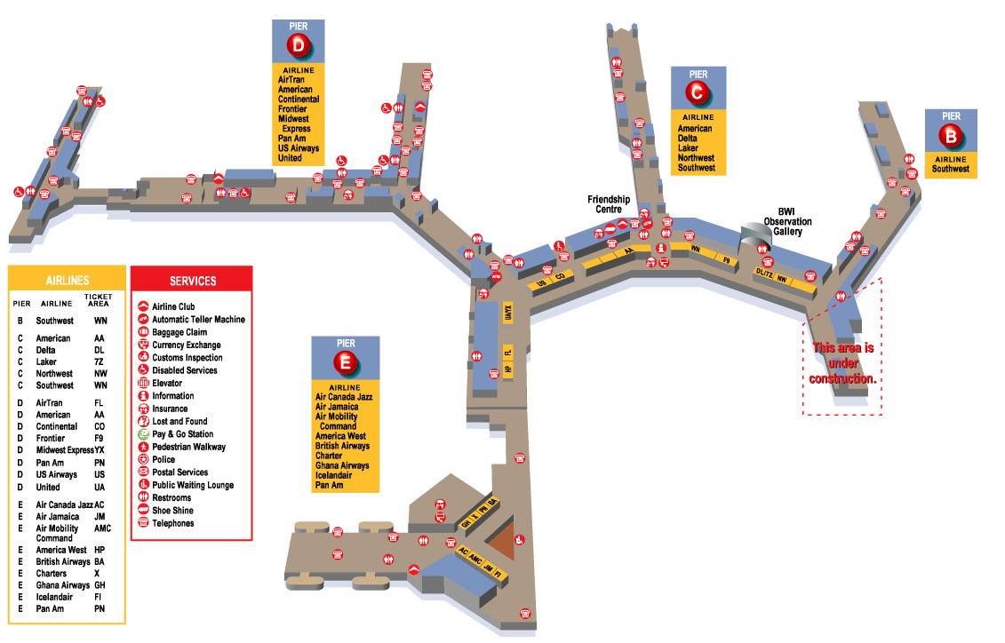
SOURCE: http://www.bwiairport.com/5custasi/tm2_10_31.gif

Moreover, BWI reported that, as a result of its extraordinary growth, the airlines’ need for gate space is at a record high. In an effort to meet the needs of the airlines and provide more frequent service and additional destinations for passengers, improvements have been made to accommodate the increased number of passengers, including “a new improved Concourse A,” with the addition of several new gates. With the completion of this stage of renovation, Concourse A will be with Terminal/Pier B, which will include 26 gates. See Figure 2 for the location of the various concessions that provide services and goods at the gates where Southwest Airlines Terminals/Piers B and C are located..

FLIGHT DELAYS INCREASE DOWN TIME IN AIRPORT

While airline carriers have not been eager to publish statistics on the length of time, “down time,” that passengers spent waiting for flights, both airports and businesses have responded: airports by expansion, with serious consideration given to new architectural designs that hopefully alleviate the increasing issue of passenger stress and boredom due to these interminable delays, while various business enterprises, responding to the increases in number of air passengers are locating a diversity of new concessions that provide goods and services previously unavailable at airports.

Particularly, business are recognizing that during this “down-time” passengers who are delayed are looking for something to do beyond eating, drinking, reading and sleeping. While there has been a diversity of new goods and services provided at airports, few of these new services have been provided at BWI. In its descriptions of “Things To Do,” while waiting at, or, more specifically, while being delayed at its airport., BWI proposes the following: activities under the category: “Things To Do,” which included the following suggestion that: “Whether you have just a few minutes to wait before your flight, or two hours to lounge away between connections [emphasis mine], BWI offers you a host of amenities that may make it hard to believe you are at an airport.” Included in their suggestions are the following: .

Food Worth Eating

There’s world-class coffee at Starbucks or an elegant meal at CK’s Restaurant. You can grab something flavorfully fast at a Taco Bell, Pizza Hut, or Burger King, or delve into some traditional Maryland fare at the Wild Goose Ale House. BWI offers you a very wide range of culinary choices in surroundings that may surprise you. Like a sidewalk café overlooking the action on the airfield.

Gifts Worth Giving

Just because you’re on the move doesn’t mean you can’t find the right little somethings for those who are extra special. How about a memento of the region? You can choose a variety from Celebrate Maryland. Or choose a gift from The Museum Company, Body Shop or Wilson’s Leather.
Time Worth Spending

Relax with a paper or magazine from Hudson News. How about the newest mystery novel from the Book Corner? Stop off in our Observation Gallery and have some fun with the interactive aviation exhibits. Or just stare out the windows and lose yourself in the activities on the airfield. The Public Waiting Lounge next to Burger King is a nice quiet spot!

A Gallery Worth Observing

While you’re in the Terminal, you really owe it to yourself (and anyone traveling with you) to visit the BWI Observation Gallery.

The above are amenities, good and services, inevitably, available at all airports, not to mention the nation’s ubiquitous shopping malls. What becomes increasingly clear is that after a 15 to 20 minute tour of the location of these amenities, and a perusal of the goods and services, there is nothing much new to do but sit and wait. Specifically, the above activities cannot suffice to fill the down time if one is delayed for several hours, which is why airports in their expansion plans to accommodate the escalating number of airline passengers have moved to increase the numbers of concessions providing unique and distinctive goods and services. But what about the business traveler at BWI?. What amenities or activities are provided, especially for the more than 70% of the adult population over the age of 25, who do not have college degrees and but are interested in advancing their careers.

At BWI, for business travelers, there is only one concession, Travelex Currency Exchange, which provides on-site business services, phone lines, Internet hook-ups, faxing, photocopying, currency exchange, and Western Union services. That company has two branches at BWI and one is located on the upper level in Terminal C near security. Also, there are three outlets for high-speed Internet access located at CK's Lounge between piers B and C, the Beer Garden at Pier C and the University Lounge at Pier D) in addition to some 103 data ports throughout the airport. At these facilities, access is not free. Travelers can purchase and, for a short time, borrow a wireless network card at each location. Also, there are flexible rate plans for access enable travelers to choose PayPerUse for 25 cents per minute, unlimited daily access for $7.95 or monthly plans for as low as $15.95. See Figure 2 for information on the specific names and locations of the various companies that provide goods and services to airport passengers at BWI.

In addition, airport shopping mall developer BAA USA (London’s Heathrow and Pittsburgh International Airport) have plans for establishing up to 100 new stores, restaurants and services at BWI. Also, BWI is open 24 hours a day, 7 days a week and in “BWI’s Blueprint for the Future,” the plans are that: “When everything is finished, getting to and from BWI will be even easier for all travelers. There will be more gates, more services, and more convenience than ever,” specifically, significantly increased food and shopping areas. See Figure 2, BWI Layout Concessions Locations.

DISTANCE ONLINE PROVIDERS FAILURE TO RESPOND TO PASSENGER DOWNTIME

With increased business travel, the airport is a particularly appropriate venue to attract potential Distance Education OnLine students, since their online education degree programs are primarily limited to working adults. As indicated in an announcement of the composite profile of the students enrolled in the on-line programs of the industry leader, University of Phoenix: (see Report 1, “THE COMPETITORS FOR TRAVELER ENROLLMENT BOOTHS AND KIOSKS FOR DISTANCE ON-LINE EDUCATON REGISTRATION AND ENROLLMENT”}, “The average age of Online students is 36. Twenty percent of the students are executives or owners of their own businesses, 30% are middle managers in business and industry, and 44% are technical or licensed professionals.” This group provides a substantial number of passengers that make up that cohort of business travelers in airports. While few airline carriers publish statistics on the length of time, “down time,” that passengers spend waiting for flights, both airports and businesses have recognized that with the increased amount of down time, new amenities for these passengers must be provided.

Airports have responded by plans for expansion, with serious consideration given to new architectural designs that hopefully alleviate the increasing issue of passenger stress and boredom due to these interminable delays. While various business enterprises, responding to the increases in number of air passengers, are locating a diversity of new concessions that provide goods and services previously unavailable at airports, incredibly, the Distance Education On-Line Industry has not pursued marketing their products, college degrees, through the use of Kiosks and traveling booths at airports.

.Perhaps, the most illustrative anecdotal example of the persistent interest or desperation that exists among airport passengers in their efforts to use their down time productively, especially in acquiring information to advance their careers, is demonstrated by the activity developed by a businessman. While waiting at BWI Gerald Haman, President of a creativity training firm in Chicago, utilized the down time between his flights, while waiting at BWI, to provide free business advice to fellow passengers. What he did was to draft a sign that stated, “Free Ideas.” Incredibly, people stood in line to present him with their business problems. Reporting on his experience he indicated that: “Over two days, I visited with over 100 people. People were handing me notes with suggestions at the airport, hotel lobbies and shuttle buses.”

Figure 2 BWI Layout Concessions Locations.
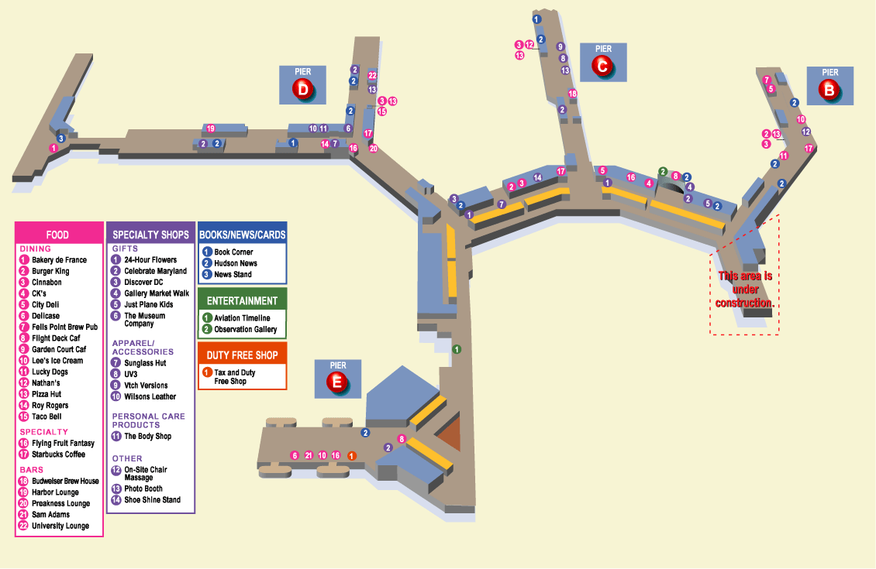
SOURCE: http://www.bwiairport.com/5custasi/tm2_10_31.gif

Yet, the Distance Education On-Line industry has not recognized the advantages of locating those Kiosks in the very space in which a substantial market of potential applicants would have the time to pursue information on advancing their education. The potential for the use of kiosks at traveling venues is detailed in my Report 2,: “If You BuilD It They Will Come: traveler Booths and Kiosks for Distance Education Enrollment at Airports, Train Stations and Retail Venues. As suggested in this report, BWI provides the most advantageous airport for the proposed pilot program. It has substantial, but not overwhelming passenger traffic and, while the airport is large, there is a central area for Terminal/Pier locations. In addition, the location of the terminals used by Southwest Airlines passengers will enable distance education on-line competitors to reach the largest number of passengers that use BWI.

SOURCES:

2005 Baltimore/Washington International Airport 2004 General Statistics

2004, Jonathan Dean, “Passenger Growth at Baltimore/Washington International Airport.” Busimess Monthly.

March 30, 2004. Gerald Haman, “Brainstorming 101: Onward, Into the Fog of Creativity,” New York Times. BUSINESS TRAVEL: FREQUENT FLIER.

2003, Laura Willoughby, “Relax and Watch those Revenues.” Busimess Monthly,
20003 BWI FACTS AND FIGURES CAPITAL PROGRAM HIGHLIGHTS

Baltimore/Washington International Airport 2004| General Statistics
 |  | General Statistics  BWI FACTS AND FIGURES  AIR TRAFFIC  Total Daily Arrivals and Departures (03/05)  GENERAL PASSENGER STATISTICS:  EMPLOYMENT  TOTAL STATEWIDE ECONOMIC IMPACT  BWI FINANCIAL RESULTS (FISCAL YEAR 2004-JULY 2003 TO JUNE 2004)  PARKING SPACES 2/05  GROUND TRANSPORTATION  *MTA did not survey Light Rail in 2001 or 2004
  OPERATOR | Operated by the Maryland Aviation Administration, Maryland Department of Transportation
  SIZE | 3,596.3 acres
  PASSENGER TERMINAL | 1.4 million square feet; 4 concourses (3 domestic, 1 international/swing); 69 jet gates, 12 gates dedicated to commuter aircraft
  Total Number of Airlines | 52 including commuter, charter, and cargo airlines
  Number of Commercial Airlines | 27
  Average Number of Daily Operations* | 837
  Average Number of Commercial Operations Per Day* | 730
  * Source: FAA CY2003
  Average Scheduled Domestic Passenger Flights | 692
  Average Charter Passenger Flights | 8
  Scheduled International Nonstop Flights | 22
  Average Cargo Flights | 24
   | 2004 | 2003 | 2002 | 2001
  Average Number of Passengers per Day | 55,578 | 53,962 | 52,089 | 55,808
  Total Passengers per Year (millions) | 20.34 | 19.70 | 19.01 | 20.36
  Percentage Change from the previous year | 3.3% | 3.6% | -6.7% | 3.9%
  Top Five Passenger Airlines by Market Share CY 2004 | Southwest (47.31%)
   | AirTran (8.75%)
   | American (7.43%)
   | United (7.22%)
   | Delta (7.11%)
  Number of Airlines Providing International Scheduled Service | 6
   | Air Canada Jazz
   | Air Jamaica
   | AirTran
   | British Airways
   | Icelandair
   | USA 3000
  Average Number of International Nonstop Destinations | 10
   | Bermuda
   | Cancun
   | Freeport
   | La Roma, BR
   | London
   | Montego Bay
   | Punta Cana
   | Reykjavik
   | Toronto
   | Caribbean
  Average Number of Domestic Nonstop  Destinations (3/05) | 63
  BWIs Top Five Domestic Origin and Destination Markets in 2004 | Orlando, Providence (RI), Atlanta,  Manchester (NH) and Boston
  ACIs 2004 North America Ranking of BWI | 24th for passengers
  Maryland Aviation Administration Employees | 557 Allocated, 519 Filled
  Estimated Total Number of Badged Employees Working at BWI (FT & PT) | Approximately 10,360
  Business Revenues for Central Maryland | $5.7 billion
  Total Direct/Induced/Indirect Jobs | 104,758
   | FY 2004 | FY 2003
  Operating Revenue | $189.44 million | $178.25
  Operating Expense | $165.34 million | $171.26
  Operating Income | $24.1 million | $6.99
  Parking facility: | Spaces | Overflow Lot: | Spaces
  Hourly Garage | 5,300 | Overflow | 5,500
  ESP | 1,800 | Rail Station | 2,000
  Daily | 8,400
  Long-Term A & B | 10,100
  Total Regular | 25,600 | Total Overflow | 7.500
  Total Spaces | 33,100
   | 2004 | 2003 | 2002 | 2001
  Total Available Regular Parking Spaces | 24,300 | 22,300 | 18,800 | 17,900
  Change from Previous Year | 8.97% | 16.62% | 5.03% | 8.48%
  Average No. Tickets Collected per Day | 10,261 | 10,215 | 9,438 | 10,971
  Change from Previous Year | 0.5% | 8.23% | -13.97% | -1.35%
  Average No. of Cars Parked per Day | 12,207 | 11,721 | 11,248 | 12,604
  Change from Previous Year | 4.15% | 4.21% | -10.76% | -1.83%
  Record No. of Vehicles Parked in One Day | 22,322 | 22,794 | 18,552 | 21,703
   | 2004 | 2003 | 2002 | 2001
  Daily Average Amtrak Station Passengers Riding Shuttle to BWI | 1,563 | 1,515 | 1,683 | 1,723
  Daily Average Passenger Riding Light Rail to BWI | N/A* | 2,400 | 1,208 | N/A*
  Daily Average Passengers Riding Shared-Ride Van Services | 1,111 | 1,111 | 938 | 1,084
  Daily Average Taxicab Trips | 1,119 | 1,052 | 1,063 | 1,106
  Daily Average Limousine Trips | 29 | 88 | 96 | 90
Source: Baltimore/Washington International Airport | General Statistics [2004], http://www.bwiairport.com/about_bwi/general_statistics/
----------------------------------------------------------------------------------------------------------

2004

Passenger Growth at Baltimore/Washington International Airport
By Jonathan Dean
Baltimore/Washington International
(BWI) Airport serves as the gateway to the world for Maryland and the entire National Capital region. Located in the heart of the fourth largest metropolitan area in the United States - the Baltimore-Washington Corridor - the airport offers a highly competitive product.
More than 2.5 million people live within a 45-minute drive of BWI and the airport continues to draw passengers from throughout the mid-Atlantic region. It also benefits from an excellent network of highways and rail service that allows BWI to attract travelers from a broad area that also includes Northern Virginia, West Virginia, Southern Pennsylvania, Delaware and New Jersey.
Those factors combine to make BWI the epicenter of a booming regional economic development hub. Paul J. Wiedefeld, executive director of the Maryland Aviation Administration (MAA), said, "BWI offers its passengers a full complement of airlines, from traditional full-service to low-fare and international carriers. It is a convenient and user-friendly airport, which offers competitively-priced service to destinations throughout the nation and the world."
BWI is vital to Maryland's economy and the airport is one of the state's most important engines. More flights and the growing number of worldwide destinations bring increasing numbers of business and leisure travelers, and more cargo, to the region.
During the past 30 years, the airline industry has shown consistent, steady growth. Even as the worldwide aviation industry works to return to normal passenger levels after an economic downturn, passenger traffic continues to increase at BWI. Throughout much of 2003, passenger figures at BWI consistently surpassed those of airports around the country. Significant increases were achieved in international traffic and a number of airline carriers have added new flights to and from BWI in recent months.
In 2003, about 19.7 million passengers traveled through BWI, an increase of 3.6% from the passenger figures for 2002. This continued growth is particularly significant when compared with the nationwide average, which showed a decline of 2.7%.
BWI is also the largest airport serving the Baltimore-Washington metropolitan area. In 2003, the number of passengers served by BWI reached nearly 3 million more than Dulles International Airport in Northern Virginia and 5.5 million more than Reagan National Airport, also located in Northern Virginia, just over the Washington, D.C., line.
International passenger figures at BWI were also positive in 2003, with BWI's international traffic increasing about 11.6% from 2002 totals. This compares to a national decline of 1.8% in international passengers. That increase was due primarily to the resumption of Aer Lingus's service to Ireland in March 2003 and AirTran's new non-stop service from BWI to Freeport, Bahamas.
BWI currently offers more than 300 daily non-stop scheduled passenger departures and non-stop flights to 74 domestic and international destinations. The airport offers a good mix of low-fare and full-service carriers. Last year, six airlines carried more than one million passengers each through BWI, the first time in history in which more than five airlines broke that figure.
Southwest Airlines is the leading carrier at BWI, transporting approximately 47% of all passenger traffic at the airport, up from 44% in 2002. Southwest currently provides 161 daily non-stop flights to 35 destinations. The other airlines that broke the one million passenger barrier last year include American, AirTran, Delta, United and USAirways.
A number of major carriers at BWI experienced significant growth in passenger levels for 2003. For example, since its arrival in December of 2001, AirTran has grown from six to 33 flights a day and its market share increased to 7.7% of all traffic at BWI in 2003. Frontier, Northwest, Continental and United all posted positive growth numbers in 2003, as well.
Wiedefeld said, "The Maryland Aviation Administration is committed to maintaining the level of service and convenience that our traveling customers deserve. A positive and successful 2003 is a clear indication that BWI remains the airport of choice in the region. The airport's ability to offer a wide variety of destinations with competitive fares, combined with our continued focus on customer service, is a winning formula."
In recent months, a number of BWI's airlines have announced new service at the airport. Southwest has added flights to Columbus, Houston, San Diego, Raleigh and Manchester, N.H. AirTran has added new service to Dayton, Milwaukee, Boston and Dallas-Fort Worth. Bermuda will also be a hot market, with announced BWI flights from USAirways and USA 3000. And Delta has added more flights to Atlanta.
BWI has excellent opportunities for continued growth. The airport recognizes the importance of a balanced air traffic base. BWI will continue its efforts to expand on the airline choices and opportunities available to its customers. In addition, the airport will focus on continuing its expansion into additional international markets.
This information all points to an exciting future. "The state will continue to do everything possible to make BWI one of the most efficient, user-friendly airports in the nation for passengers, airlines and cargo," said Wiedefeld. "This commitment to excellence will ensure that BWI meets the challenges of the future for the residents and businesses of Maryland."
Jonathan Dean is the manager of communications for BWI Airport. He can be reached at 410-859-7719 and jdean@ bwiairport.com.
Source: http://www.bwiairport.com/8abtbwi/in_gs.shtml
----------------------------------------------------------------------------------------------------------
April 3, 2004

Brainstorming 101: Onward, Into the Fog of Creativity
Gerald Haman
President of SolutionPeople, a creativity training firm in Chicago
Last November, I got stuck for two nights in the San Francisco airport on my way to Australia. With hundreds of people milling around, I pulled out an innovation tool I invented called the KnowBrainer and scribbled a sign on paper I got from a ticket agent that read: "Free ideas from Solutionman! I will help you with your goals, challenges or problems while you're waiting."
Much to my surprise, people lined up to get advice. At first I sat on a seat and later on the carpet with the KnowBrainer, which looks like a deck of cards with questions and quotations, inviting people to sit with me, one by one. An inventor was trying to think of variations on his technology-storage device, which he had been working on for over five years. He said he was dreaming about algorithms. Though he had gotten stuck on one particular formula, an Einstein quote in my game seemed to spark some ideas.
An attractive young lady in a revealing outfit actually wanted to brainstorm ideas on how "we" could vacation together in Australia. I had to politely tell her I was traveling on business - and married. We then talked about how she could improve her social life and find a boyfriend.
Most of her dates asked the same old questions, like where she went to school, and talked too much about themselves and sports. She decided to try to spice up her e-mail exchanges and phone conversations with men she met on her online dating service.
Then there was a marketing consultant who wanted to bring more "emotion" to an advertising campaign. He showed me some original storyboards, which featured nature scenes and soft colors. But one purple leaf stood out, and after talking with me, he concluded he ought to use more strong colors like purple.
Over two days, I visited with over 100 people. People were handing me notes with suggestions at the airport, hotel lobbies and shuttle buses.
I'm a strong believer in a correlation between your environment and creativity. I also believe you should take your shoes off to think properly. If your feet are comfortable, your brain will be comfortable.
I've brainstormed in an English castle, on a ship and in a Singapore stadium with 8,000 people, but I found an airport to be a superb place for mental exercise. Lots of space, billboards and things to look at. And you can take your shoes off.
As told to Sharon McDonnel
Source www.nytimes.com/2004/03/30/business/30flier.html - 43k -
=============================================
2003
Relax and Watch those Revenues
By Laura Willoughby
Travel may be down overall, but it hasn't stopped one BWI vendor from growing and expanding. In case you haven't heard of this success story yet, pay attention: There's something to be said about location and the right timing.
Two years ago, Laurie Sears opened Destination Relaxation on Pier B at BWI, where airline passengers could sit down for a short 10-minute or longer 90-minute seated massage. Since then, revenues have been soaring, enough so that Sears could open another location, this one in a retail storefront, on Pier D.
Since she opened the Pier B kiosk, revenues have quadrupled, Sears said, and employees have grown from just two to 18 massage therapists now. It helps that the original Destination Relaxation is in the Southwest terminal, the one airline that continued with steady passenger numbers even in the wake of Sept. 11's travel shutdown.
The newest location is an expanded version of what massage clients find on Pier B-it's more of a mini-spa, Sears said, and features a massage table for full massages and a recliner featuring a foot massage along with the now-standard seated massages. The expansion was funded entirely from existing revenues.
To what does Sears attribute her business growth? Location and new-found travel stress. "Sept. 11 has made travel more stressful," she said. "Passengers are dealing with security and lines, and people are really stuck in the terminal once they're inside, but have to occupy their time." Massage, it would seem, is becoming a recreation of choice to pass the time.
=======================================================
20003 BWI FACTS AND FIGURES CAPITAL PROGRAM HIGHLIGHTS
New Concourse A and B

As a result of BWI’s extraordinary growth, the airlines’ need for gate space is at a record high. In an effort to meet the needs of the airlines and provide more frequent service and additional destinations for passengers, a new improved Concourse A opens early in 2005, adding several new gates. When Concourse A is complete and it is connected with Pier B, the area will include 26 gates.

The Concourse will offer a baggage claim area, passenger hold rooms, ticket counter space and significantly increased food and shopping areas.

Terminal Improvements

We are expanding the width of the terminal. Additional space will be added to the entire terminal to provide more space in front of ticket counters and in baggage claim areas. The width of the terminal increases ten feet with new window walls, elevators, escalators and stairways.

Over the next few years, you’re going to see major changes at BWI. While construction is underway, please bear with us as we expand our terminal and improve our roadways. The overview below will let you know what’s in store. When everything is finished, getting to and from BWI will be even easier for all travelers. There will be more gates, more services, and more convenience than ever.

Whether you fly BWI, or pick-up or drop off a passenger, the BWI Blueprint for the Future will make visiting BWI better for you in just a few short years. In the meantime, refer to this and other updates for details on road changes and completed portions of the project.
2002
Fall
New Terminal Access Return Road Opens
3,000 Spaces Open in the New Daily A Garage
Airport Employee Tenant Lot Opened

2003
Fall
Rental Car Facility Will Open
3,200 Additional Spaces Open in New Daily A Garage
Pier D Skywalk with New Elevators/Escalators Will Open

2004/2005

Spring 2004
Concourse B Skywalk with New Elevators/Escalators Will Open
New Daily A Garage Complete with 8,400 Spaces
Spring 2005
New Concourse A Opens with New Gates, Skywalk, Food Court and Elevators/Escalators
Fall 2005
Concourse A/B Connection Complete

2006

Summer
Terminal Widening Complete with Upgrades to Ticketing Concourse and Baggage Claim Areas

Fall
Upper and Lower Level Roadway Widening Will be Complete
For Up-To-Date Information and the Latest Construction News:
Call… 1-800-IFLYBWI

Jeffrey E. Walker
AlkerJ & Associates Educational Consulting
Columbia, Maryland
alkerj@verizon.net
410-997-1284

alkerJ & Associates Educational Consulting, established by Jeffrey E. Walker, specializes in Distance Education, providing planning and consulting services and business development proposals.. Mr. Walker has had ten years of experience in higher education at Johns Hopkins, Southeastern University (DC) and, presently, the University of Maryland University College (UMUC), Department of Student Affairs/ Degree Audit Team (DAT), as Advanced Evaluator / Senior Advisor, with responsibilities in providing advising information to nontraditional students in UMUC degree programs in online distance education programs as well as to UMUC’s brick and mortar students, including course planning, degree and certificate completion requirements, registration, program changes, and Bachelors’ degree course evaluation.

alkerJ & Associates Educational Consulting also provides conference planning and develops community historic preservation activities. Mr. Walker is President of the Free Frank New Philadelphia Historic Preservation Foundation and has appeared in The Learning Channel (TLC) documentary, "Understanding Mysteries of Memory. " He has won service and planning awards from the American Society for Photogrammetry and Remote Sensing,(ASPRS), the University of Maryland University College, and the University of Texas at Austin’s Center of Black Business History, Entrepreneurship. Technology. Jeffrey Walker has a B.A. in American History, Loyola University, Chicago, IL, with graduate work in the School of Education, Loyola College, Baltimore, MD. He has published entries in the Encyclopedia of African American Business History and has written several Distance Education reports including: “The Competitors for Traveler Enrollment Booths and Kiosks For Distance On-Line Education Registration and Enrollment, “’If You Build It They Will Come ‘: Traveler Booths and Kiosks, for Distance Education Enrollment at Airports, Train Stations and Retail Venues,” and “Advantages to Locating Kiosks and Traveler Booths at Baltimore-Washington Thurgood Marshall International Airport.”

